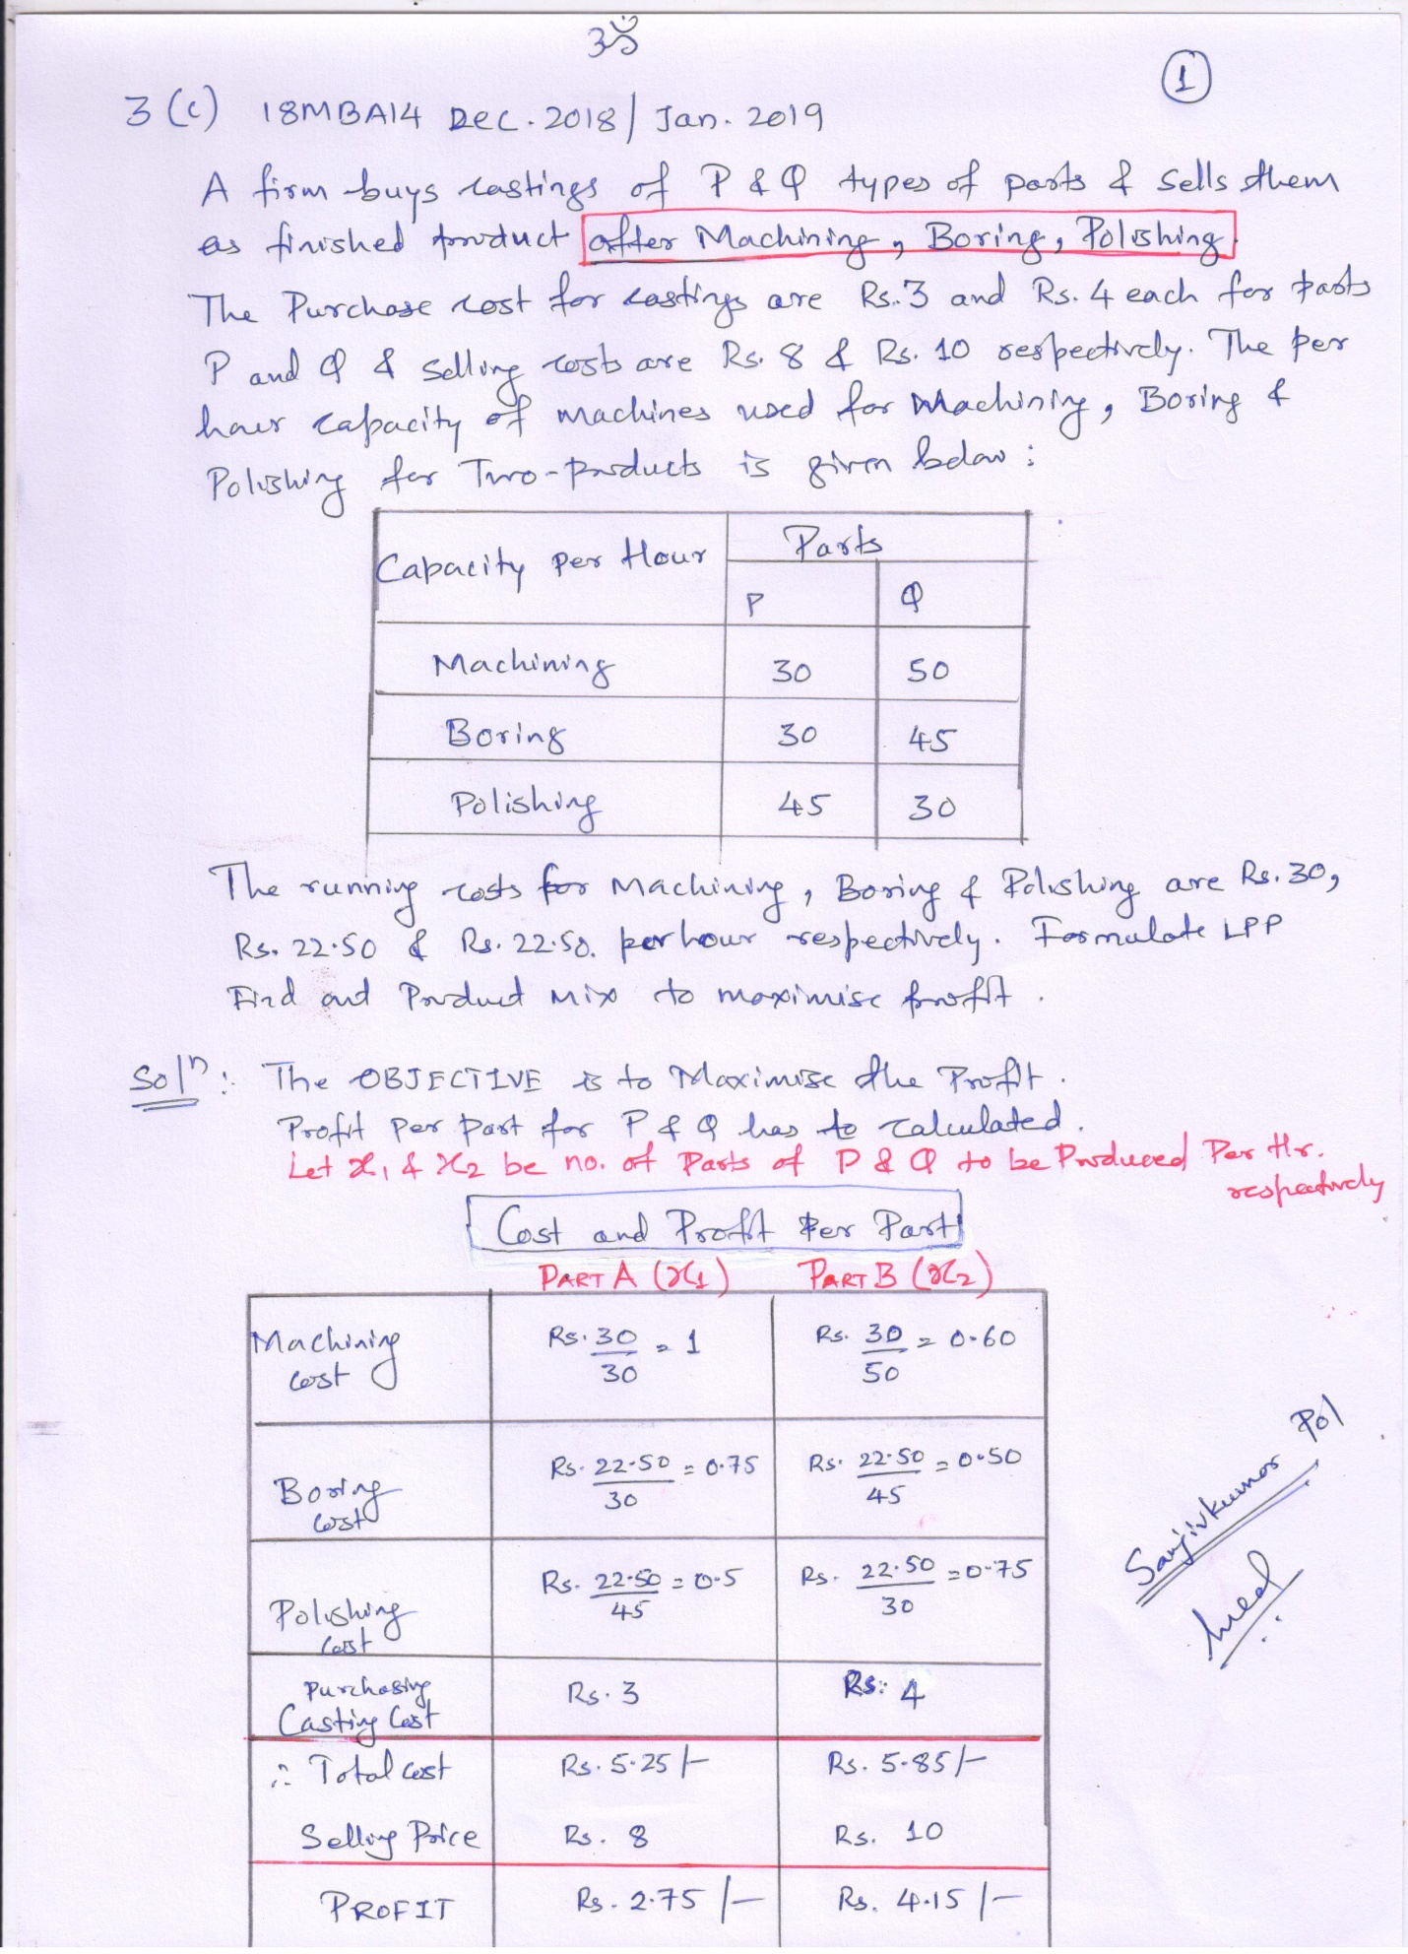
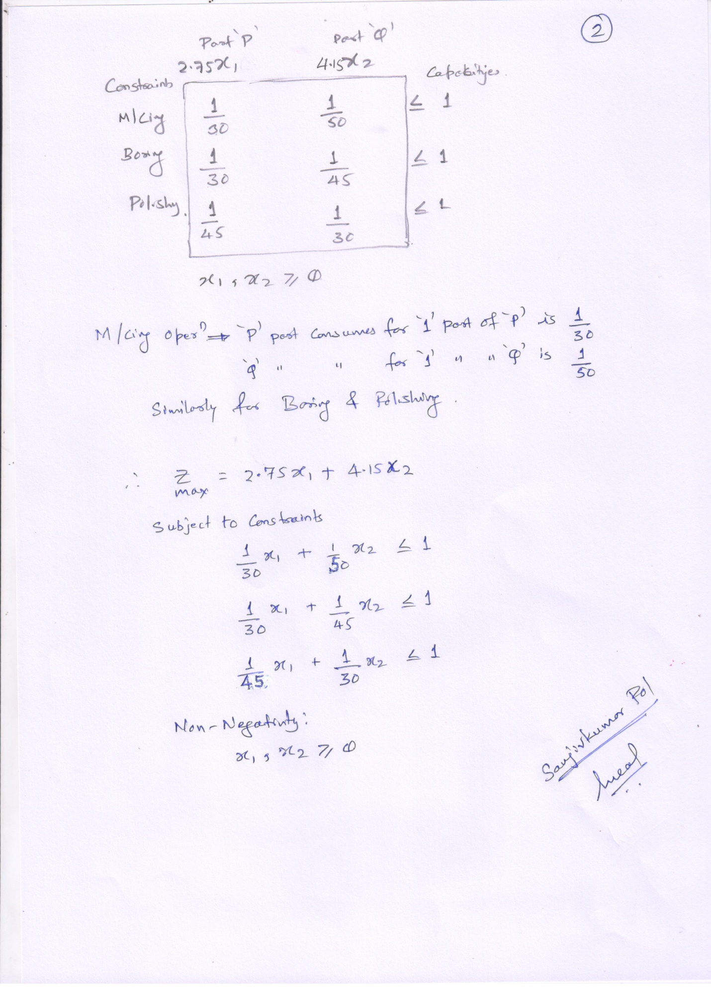
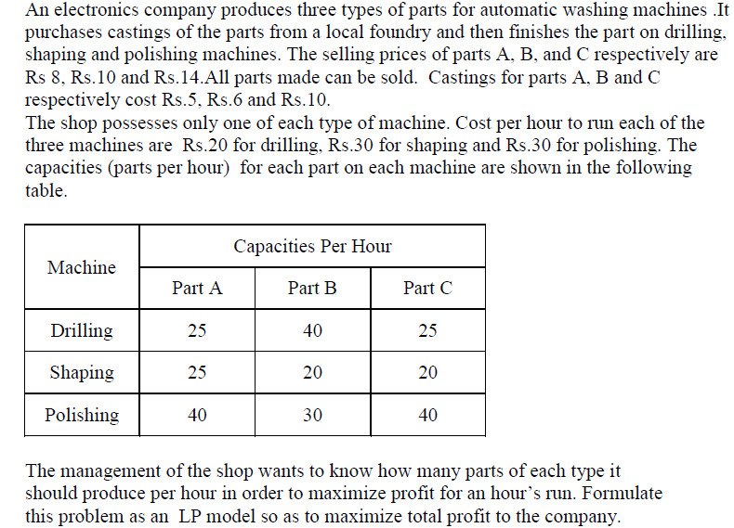

SOLUTION:

Part A Should undergo DRILLING, SHAPING AND POLISHING… Same with B and C

PART A PROFIT = 8 – (5 + COST of DRIL + COST of Shape + COST of Polish)

same with B & C…… as per their respective given Prices.

Part A = 8 – ( 5 + (Rs. 20 per hr drilling divide by 25 parts per hr )
+
(Rs. 30 per hr shaping divide by 25 parts per hr )
+
(Rs. 30 per hr polishing divide by 40 parts per hr )

Part A = 8 – ( 5 + 0.8 + 1.2 + 0.75) = 0.25 per piece of Part A

Solve for PART B & PART C

Decision variable
Let X1 and X2 and X3 be the number of types A, B and C parts produced per hour
respectively .

objective function
Maximize Z = 0.25 X1 + 1X2 + 0.95X3

PER PART BASIS WE NEED TO ALLOCATE
Constraints are capacity per hour given for parts….

RESOURCE | Part A X1  Per Part | Part B X2  Per Part | Part C X3  Per Part | CAPACITY
DRILLING | 1/25 | 1/40 | 1/25 | < = 1
SHAPING | 1/25 | 1/20 | 1/20 | < = 1
POLISHING | 1/40 | 1/30 | 1/40 | < = 1

Non-Negativity ===== Where X1, X2, X3 ≥ 0

